Feedback page

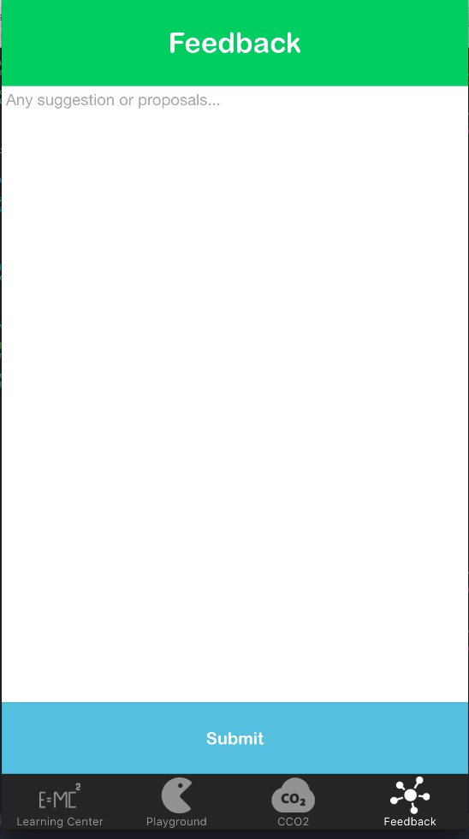

Instead of **any suggestions or proposals. . . . .** please add:

We welcome your feedback, comments or questions about:

* the contents of this App;
* the university’s waste and recycling facilities; or
* sustainability more generally.

For more information about waste and recycling on campus, check out the Ecoversity website [www.adelaide.edu.au/ecoversity](http://www.adelaide.edu.au/ecoversity) or find us on facebook.

Can you also change the Submit bar so that it looks more like a button that people have to press? e.g.

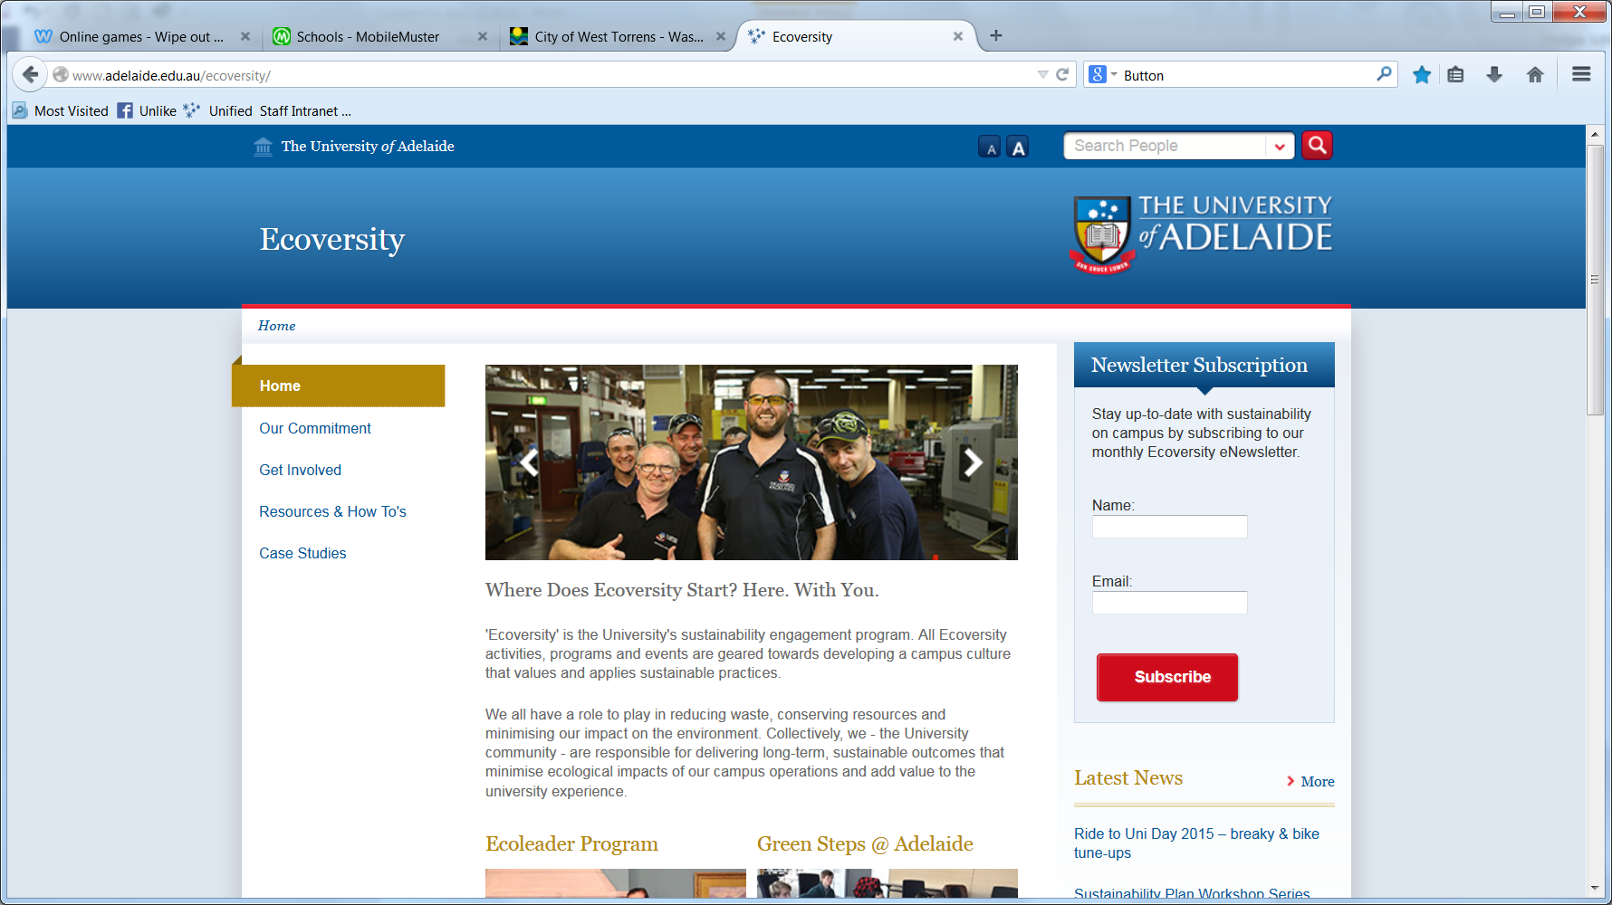

Playground page

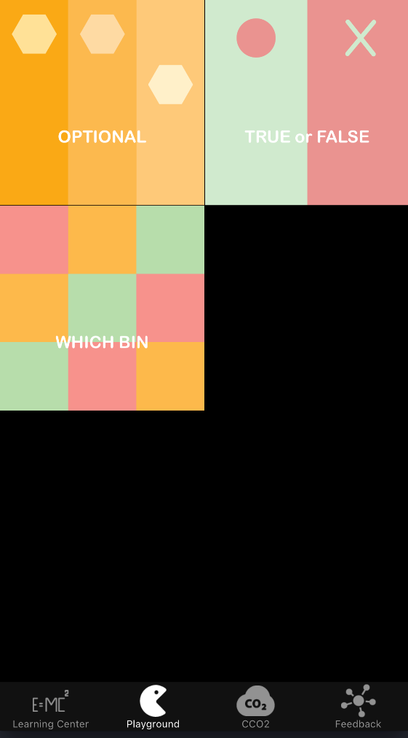

Please add to the top of the page above the boxes:

**How much do you know about waste and recycling?**

Play to find out.

Please change the name of the games to:

* RECYCLING QUIZ (instead of Optional)
* TRUE or FALSE
* SORT YOUR WASTE (instead of Which Bin)